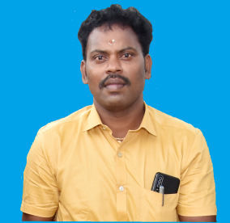

**STAFF PROFILE**

|  |  |  |
| --- | --- | --- |
| Name | : | **Mr.V.SARAVANAKUMAR** |
| Designation | : | **Librarian** |
| Qualification | : | **M.Com.,MLISc.,NET,MBA, DCA,**  **PGDLAN** |
| Experience | : | **14 Years** |
| Educational Institute | : | **MLIS – Bishop Heber College, Trichy** |
| **NET - UGC** |
| **M.Com – Annamalai University, Chidambaram** |
| **M.B.A. – Bharathidasan University, Trichy** |
| **PGDLAN – Annamalai University, Chidambaram** |
| **DCA – Vidiyal Computer Education, Trichy** |